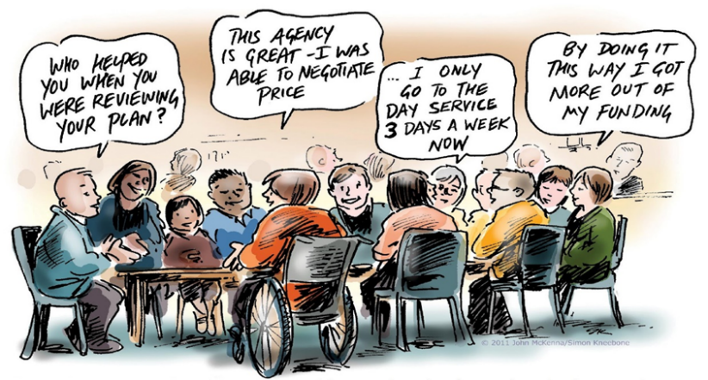


In partnership with
Invite you to join the

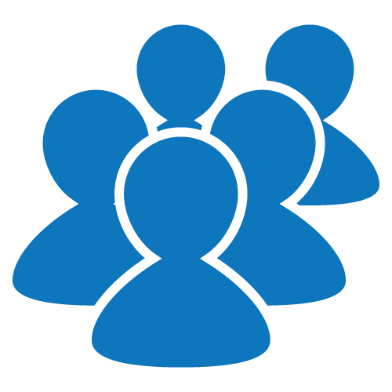
Bairnsdale Peer Action Group
Peer Action Groups provide peer support and encouragement for people with disability to:
2021 Dates
January 19th
February 9th
February 23
March 9th
March 23rd
April 13th
April 27th
May 11th
May 25th
June 8th
June 22nd
- Network with other people experiencing the same situations, needs and issues.
- Learn to make NDIS supports work to achieve personal goals and become more able to make decisions and choices
- Create relationships and friendships that empower and create confidence
- Increase opportunities for recreation, work, and community participation
- Develop self-advocacy skills and learn to access independent advocacy support when needed
- Do projects together to improve and promote more inclusive communities for everyone

www.gdai.com.au
www.valid.org.au

10am – 12 noon at The Hub, 27 Dalmahoy Street, Bairnsdale.


For more information please contact Annette Axen at VALID on:
0407 375 633 annette@valid.org.au

