**VALID – Calls to Action**

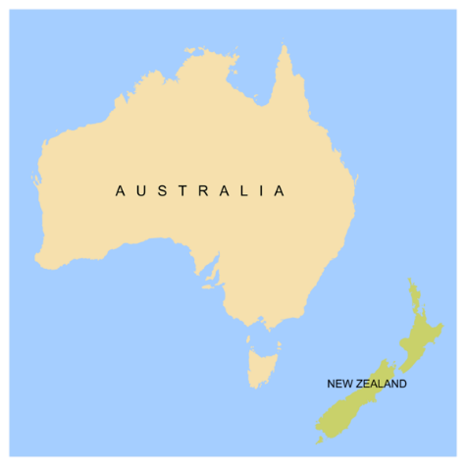

VALID is asking the Federal Government to make some changes.

The Federal Government is the Government of Australia.



**Call to Action 1:**

**Make a centre called the National Resource Centre.**This centre will be a place where people can learn about Supported Decision Making.

**Call to Action 2:**

**Make training that professionals can get from the NDIS Quality and Safeguards Commission.**This training will help professionals learn how to support people to make decisions.

**Call to Action 3:**

**Make sure NDIA staff who work with people with disability do training on supported decision making.**



**Call to Action 4:**

**Get ideas and feedback about the Disability Royal Commission and NDIS Review from:**

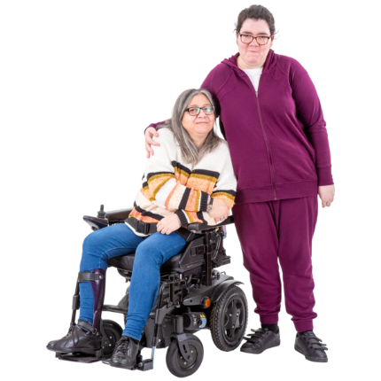

* People with intellectual disability
* Their families and supporters.

**What VALID is asking the State Government to do**

The State Government is the Government of Victoria.



1. **Give money to groups and projects that support people to make their own decisions.**

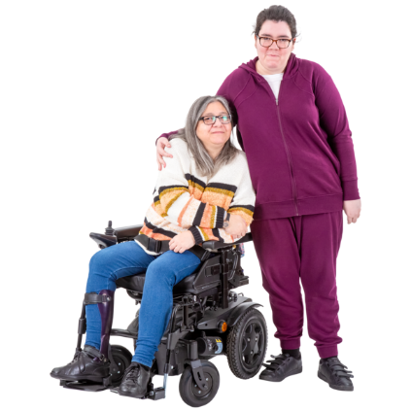

1. **Give money to help families learn how to support their family member to make their own decisions.**
2. 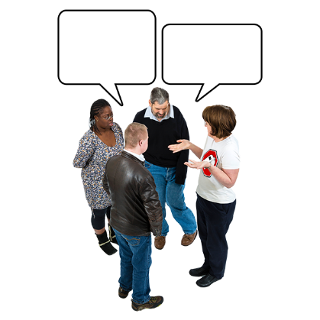**Give money to help people with disabilities join self-advocacy and peer groups so they can:**

* Speak up for themselves
* Support other people.

1. **Get ideas and feedback about the Disability Royal Commission and NDIS Review from:**



* People with intellectual disability
* Their families and supporters.

