**VALID Supported Decision Making (SDM) Principles**

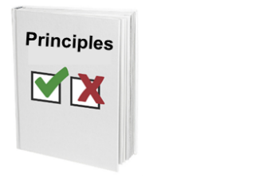

Principles are like rules that say how to do things.

**Principle 1**

**People should work with you to find out what you want.**

VALID wants to help people with intellectual disability make decisions.



A decision is when you make a choice between two or more things.



VALID says people should listen to what you want.

This is so they can help you get your goals.

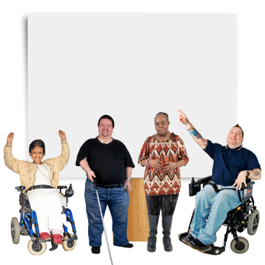

**Human Rights**

If people cannot find out what you want, they should make sure you get your Human Rights. Like a house to live in.

**Principle 2**

**People should make sure you are safe.**

VALID says people should make sure you get:

* what you want
* what you need
* support if you need it to keep you safe.

It can be good to have more people in your life to support

you to:

* make decisions
* help keep you safe.

**Principle 3**

**What to do with conflicts of interest**

A conflict of interest can be when people have to follow more than one idea or rule at the same time.

These rules or ideas might not always work well together.

Like when a support worker has to follow work rules.

These work rules might make it hard for them to support you

to do things you want.

People who support you to make decisions should

* listen to you
* help you do what you want.

Family members can have a conflict of interest.

This can be when they stop you doing things you want because they:

• care about you and worry that what you want is not safe

• want you to do what they choose.

VALID says:

* 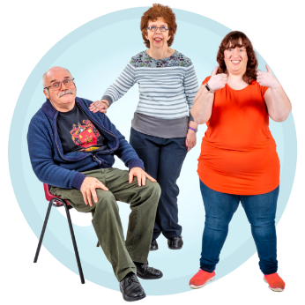Support workers and family members can be very important when you make decisions
* You also have the right to get support from people who have less conflict of interest.

**Principle 4**

**People should think you can make decisions.**

VALID says people should know that you can make your own decisions. This is true even if people

* are not sure if you can
* do not think you can.

When a decision is hard to make, people should still help you if you want them to.



This helps you be in charge of your life.

**Principle 5**

**People with intellectual disability have the right to make decisions about their lives.**

VALID says:



* you have the right to make decisions about your life
* you should be able to make your own mistakes and learn from them.

Like, if you start to learn something and decide you do not want to do it anymore.

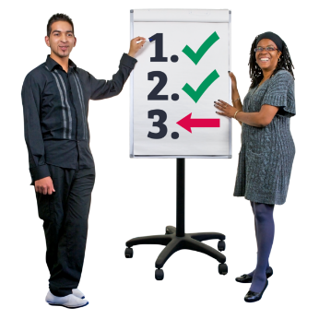

You should be able to stop doing it or change and do something else.

VALID’s 5 principles for supported decision making help keep you safe when:



* you make decisions
* people who support you have other ideas about what is best for you.



It is okay to get things wrong.

You can learn from your mistakes.

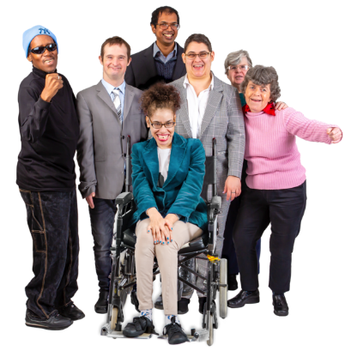VALID wants you to:

* make your own decisions
* be in charge of your life
* have people in your life who respect you and can support you to make decisions.

VALID believes in you and your rights.

