
People with Intellectual Disability Can Be Board Members
This information is in Easy Read.

The first time we write a hard word we will:
• write it in bold
• write what it means.

What this paper is about

This paper gives legal advice about people with intellectual disability being board members.
Legal advice means:
- what laws we need to follow.

- what the law says.
Laws are like rules.
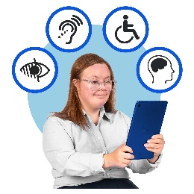
Intellectual disability means some people:
        - learn differently
        - understand information differently
        - may need support with some things.





A board member is a person who helps make important decisions for an organisation.
Some people have said that people with intellectual disability cannot be board members.

The legal advice says this is not true.
This means:
A person with intellectual disability should not be stopped from being a board member just because they have a disability.
Everyone is different
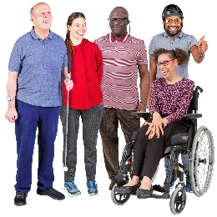
People with intellectual disability have different:
- Skills. This means things they are good at and know about
- Experiences. This means things people have done and learned from

- support needs.
Some people may need a lot of support.

Some people can:

- make decisions
- share ideas
- learn new things
- be leaders on a board.

This means:

You cannot decide if someone can or cannot be a board member just because they have intellectual disability.
Making decisions
The job of a board member means sometimes making decisions.

A person can make decisions if they can:
- understand information
- think about choices
- share what they think

- share their decision and why they made it.

People can use support to help make decisions.

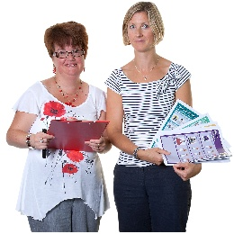
Support might be things like giving people:
- information in a way they understand like:

- Easy Read
- pictures and drawings
- talking to them
- having more time to learn about the information



This means:
People should be supported to make decisions, not left out because they need support.
Skills and lived experience
Boards need people with all kinds of skills and lived experience.
A board might need people who understand:
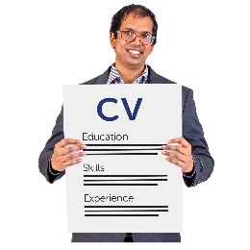
- money
- laws
- communities
- organisations
- who the board supports.

People with intellectual disability bring important lived experience.
This means:
People with intellectual disability can bring their ideas and things they know about to a board.


Everyone should have a fair chance

It is not fair to say a person cannot be a board member because they do not have some skills, if other board members are also not expected to have that skill.
Boards should make sure all members have the information and support they need.
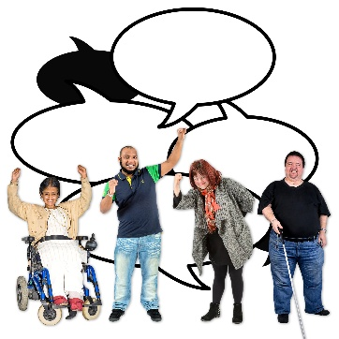
This means:
Good support helps people to:
- have their say
- be a part of things.

The important message
A person with intellectual disability can be a board member
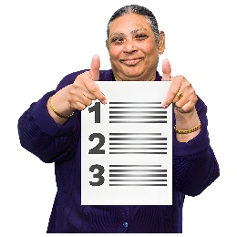
if they:
- understand their role or job
- can make decisions by themselves or with the right support
- have skills and experience to help them to be part of things
- are supported in the way they need.
This means:
People with intellectual disability can:
- be leaders
- be on a board
- and have a say in decisions made by a board


Easy Read Ph: 9416 4003
www.validconnect.org.au Images may not be reused
Made with

